# 

# **Department of Computer Science and Engineering Islamic University of Technology (IUT)** A subsidiary organ of OIC

# **Laboratory Report**

# CSE 4412: Data Communication and Networking Lab

## 

## **Name: Khalid Hasan Ador Student ID: 210042102 Section: B Semester: Summer Academic Year: 2023-2024**

**Date of Submission: 01/03/2024**

### **Title:** Configuring and Verifying of RIP and OSPF in a network topology.

### **Objective**:

### 

### **Devices/ software Used**:

### **Theory:**

*(Explain in brief the listed keywords)*

**Routing Information Protocol (RIP):** is a dynamic routing protocol that uses hop count as a routing metric to find the best path between the source and the destination network. It is a distance-vector routing protocol that has an AD value of 120 and works on the Network layer of the OSI model. RIP uses port number 520.

**Forwarding Table used in RIP:**

A table to make decisions about where to send received frames.

**Hop Count as cost**

* The hop count represents the number of routers between the source and destination networks.
* RIP aims to find the path with the fewest hops and places it in the routing table.
* The maximum hop count allowed in RIP is 15, and a hop count of 16 indicates network unreachability**.**

**Timers in RIP:**

* **Update timer:**The default timing for routing information being exchanged by the routers operating RIP is 30 seconds. Using an Update timer, the routers exchange their routing table periodically.
* **Invalid timer:**If no update comes until 180 seconds, then the destination router considers it invalid. In this scenario, the destination router mark hop counts as 16 for that router.
* **Hold down timer:**This is the time for which the router waits for a neighbor router to respond. If the router isn’t able to respond within a given time then it is declared dead. It is 180 seconds by default.
* **Flush time:**It is the time after which the entry of the route will be flushed if it doesn’t respond within the flush time. It is 60 seconds by default. This timer starts after the route has been declared invalid and after 60 seconds i.e time will be 180 + 60 = 240 seconds.

### **Diagram of the experiment:**

*(Provide screenshot of the final network topology. Make sure to label the network components.)*

**Task #01:**

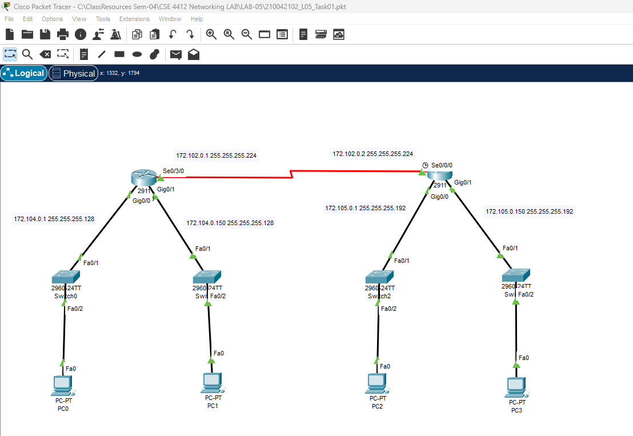

**Task #02:**

**Task #03:**

### **Working Procedure:**

***(****Explain in brief how you completed the tasks. Provide necessary screenshots of used commands for each task.)*

**Task #01:**

* 1. We have 2 routers. First of all we need to configure the interfaces of those 2 routers.
  2. Then we need to configure the pc.
  3. At last we need to configure RIP in both routers:

R1 (config)#router rip

R1 (config-router)#version 2

R1 (config-router)#network 172.102.0.0

R1 (config-router)#network 172.104.0.0

**Task #02:**

**Task #03:**

### **Q/A for the tasks:**

***(****There were many q/a sections inside the task pdfs. Copy the questions and your answers here.)*

**Task #02:**

**Task #03:**

### **Observation**:

### **Challenges (if any):**

**References:**

1. [Routing Information Protocol (RIP) - GeeksforGeeks](https://www.geeksforgeeks.org/routing-information-protocol-rip/)